- Wireshark Lab:
  - It was amazing to try out Wireshark in this lab. This is very new to me, and to be able to see everything that is happening in real-time, regarding the flood of information that your computer is handling every second is truly spectacular. To start, I opened up the Wireshark application on my MacBook Air, opened up Google Chrome while connected to my home WiFi, and followed the steps for “Taking Wireshark for a Test Run”. This started with running the packets for my connection in Wireshark, going to the designated URL in Google Chrome, filtering to HTTPS, and then selecting the line that is the GET message for me entering the URL, as shown below.
  - 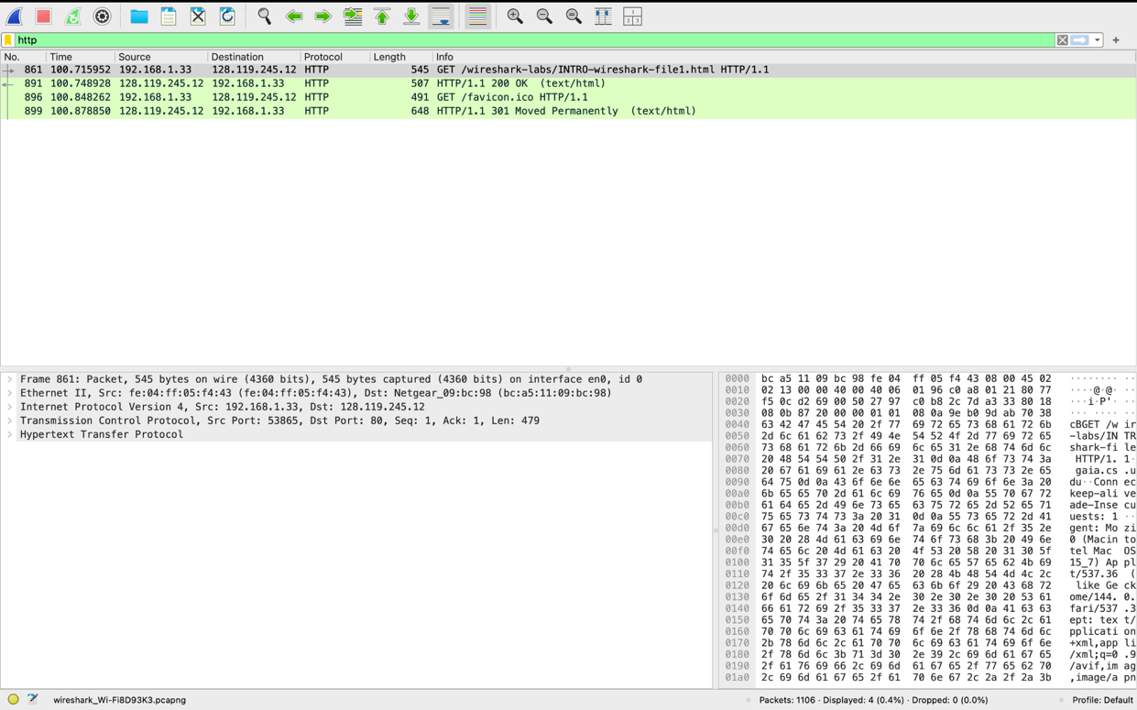
  - Next, I was directed to do more perusing of the packets that Wireshark was able to gleam from the time that it was capturing. Firstly, in the unfiltered packet-listing window I was able to find multiple different protocols that were being used beyond HTTP, such as DNS (which is the Domain Name System which is the system querying for an IP address), TLSv1.3 (version 1.3 of the Transport Layer Security and is the more up-to-date version and encrypts the information that is being sent between the computer and the server), and ARP (is the Address Resolution Protocol that finds devices on your local network and links an IP address to a MAC Address to send retrieved information to). Secondly, between the “GET” and the “OK” message from the Umass website, it was roughly 0.04 seconds which is so fascinating to see in real-time. Thirdly, it was incredibly interesting figuring out how to read more details of the Wireshark packet, such as when doing the HTTP filter for the query to Umass, I could tell which is my IP address and which is Umass’ IP address by looking at the “GET” message line, and my IP Address (192.168.X.XX) will be the Source and the Umass website (128.119.245.12) will be the Destination. Finally, I have saved as a PDF from the Print function of the two GET and OK packet lines from Wireshark which are submitted separately.

